UPCOMING OCTOBER EVENTS |  |  |  | THURSDAY |  | FRIDAY |  | SATURDAY
  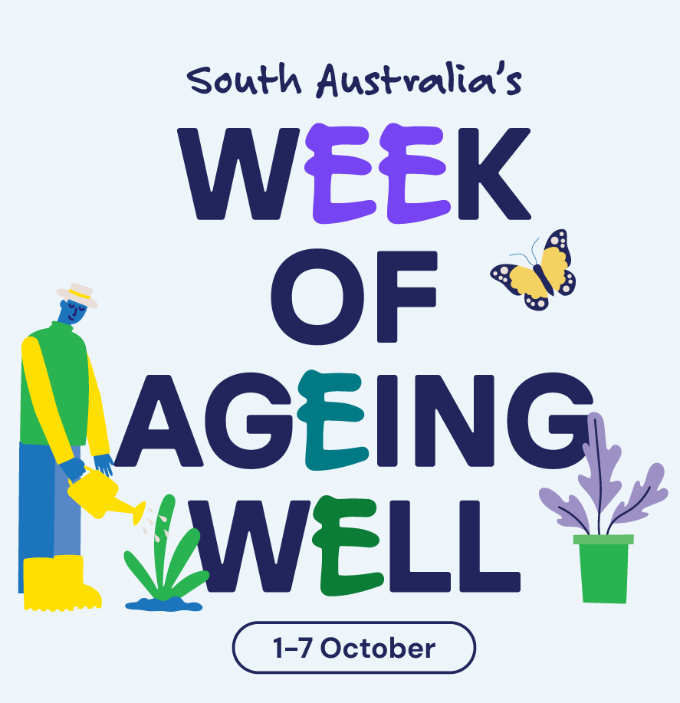  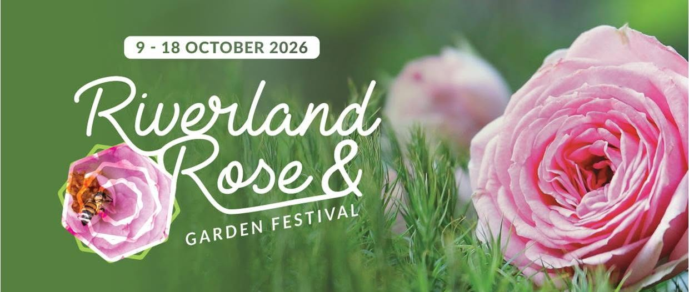 |  |  |  | 1st ^{Week of Ageing Well}  10:30 – 11:00am  Chair Exercises    11:00 – 11:30am  Newspaper Reading  2:00 – 3:00pm    Anne Battams Community Singalong in the Chapel |  | 2nd ^{Week of Ageing Well}  9:00 – 10:00am  Pancake Morning Tea with Nieske    10:30 – 11:30am  Scattegories Word Game  1:30 – 3:30pm  Nature and Nostalgia – Join us out in the garden and bring along a photograph or item to share a favourite memory of yours! |  | 3rd ^{Week of Ageing Well}  10:45 – 11:15am    Chair Yoga  11:15 – 12pm    Hookey / Quoits  1:30 – 3:30pm  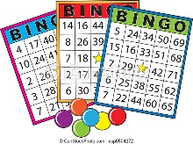  BINGO
SUNDAY | MONDAY | TUESDAY | WEDNESDAY | THURSDAY |  | FRIDAY |  | SATURDAY
4th ^{Week of Ageing Well}  10:45 – 12pm  Lutheran Church service DVD in the Edwards Rec Room    1:30 – 3:30pm    Games Afternoon | 5^{th Week of Ageing Well}  SHOW WEEK ^{Labour Day Public Holiday}  10:00 – 10:30am  A performance by Della  10:30 – 11:30am  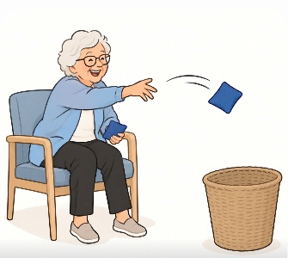  Mini Sheaf (beanbag) Toss  1:30 – 3:30pm    Show Weeks Prize Biscuit Challenge (cookery - class 1666) | 6^{th Week of Ageing Well}  SHOW WEEK  10:30 – 11:00am  Short Walking Group  11:00 – 11:30am  Long Walking Group    (weather permitting)  11:00 – 11:30am  Beauty Therapy  1:30- 3:30pm  Farmer Darcy’s Travelling Farm   | 7th ^{Week of Ageing Well}  SHOW WEEK  10:30 – 11:30am    Chapel  1:30 – 3:00pm  BINGO    3:00 – 3:30pm    Book Club | 8th  SHOW WEEK  9:30 – 10:30am  Loxton Library Visit  10:30 – 11:30am    Magic Show with James the Magician!  2:00 – 3:00pm  Anne Battams Community Singalong in the Chapel |  | 9th  SHOW WEEK  10:30 – 11:30am  Scenic Bus Trip  10:30 – 11:30am    Join us to watch the 1995 movie ‘Babe’ in the Edwards Recreation Room  1:30 – 3:30pm    Side Show Alley |  | 10th  10:45 – 11:15am  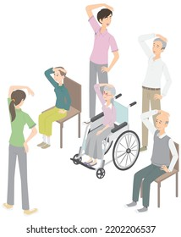  Chair Exercises  11:15 – 12pm    Balloon Tennis  1:30 – 3:30pm  BINGO
SUNDAY | MONDAY | TUESDAY | WEDNESDAY | THURSDAY |  | FRIDAY |  | SATURDAY
11th Riverland  Rose & Garden Festival  10:45 – 12pm  Lutheran Church service DVD in the Edwards Rec Room    1:30 – 3:30pm Mindfulness Colouring of flowers with Dakota for the Riverland Rose and Garden Festival | 12th Riverland  Rose & Garden Festival  10:00 – 11:30am  Resident and Representative’s Meeting    1:30 – 2:30pm  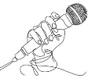  Julie Noble Live in Concert  1:30 – 2:30pm    Riverland Rose & Garden Festival Outing & Afternoon Tea at MacEden  3:30 – 4:30pm  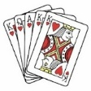  Mingle with Maxine | 13th Riverland  Rose & Garden Festival  9:00 – 9:30am  Walking Group  10:00 – 11:00am  Beauty Therapy  10:00 – 12:00pm  Riverland Rose & Garden Festival Devonshire Morning Tea and Native Floral Art Demonstration at the Loxton Historical Village    1:30- 3:30pm Monthly Birthday Celebrations  1:30- 3:00pm  Riverland Rose & Garden Festival Guided Tour of The Pines & Devonshire Afternoon Tea | 14th Riverland  Rose & Garden Festival  10:30 – 11:30am    Chapel  10:30 – 11:30am  Riverland Rose & Garden Festival Outing to Medea House    1:30 – 3:00pm  BINGO    3:00 – 3:30pm    Book Club | 15th Riverland  Rose & Garden Festival  10:30 – 11:30am  Riverland Rose & Garden Festival    Scenic Bus Tour The Gardens of Loxton  10:30 – 11:00am  Chair Exercises  11:00 – 11:30am  Newspaper Reading  2:00 – 3:00pm  Anne Battams Community Singalong in the Chapel |  | 16th Riverland  Rose & Garden Festival  10:30 – 11:30am    Riverland Rose & Garden Festival Mini Silo Art Tail Walk  10:30 – 11:30am  Let’s Get Trivial!  1:30 – 2:30pm  Riverland Rose & Garden Festival    Scenic Bus Tour The Gardens of Loxton  1:30 – 3:30pm    Gardening themed Paint n’ Sip to celebrate the Riverland Rose and Garden Festival |  | 17th Riverland  Rose & Garden Festival  10:45 – 11:15am  Chair Yoga  11:15 – 12pm  Mini Golf  1:30 – 3:30pm  BINGO
SUNDAY | MONDAY | TUESDAY | WEDNESDAY | THURSDAY |  | FRIDAY |  | SATURDAY
18th  10:45 – 12pm  Lutheran Church Traditional Service DVD in the Edwards Rec Room  1:30 – 3:30pm  Reminiscing on days gone by… Let’s chat about our gardens! 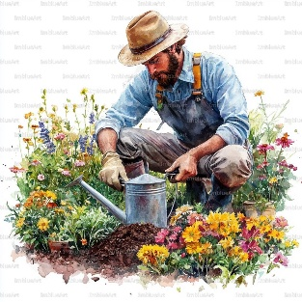 | 19th  10:30 – 11:30am  Chair Exercises  11:00 – 11:30am  Magnetic Darts    1:30 – 3:00pm    Indoor Bowls  3:30 – 4:30pm    Mingle with Maxine | 20th  10:30 – 11:00am  Short Walking Group  11:00 – 11:30am  Long Walking Group  (weather permitting)  11:00 – 11:30am  Beauty Therapy  1.30pm – 3.30pm    The World’s Kitchen – This month we’re travelling to Germany for Oktoberfest! | 21st  10:30 – 11:30am  Chapel  1:30 – 3:00pm  BINGO  3:00 – 3:30pm  Book Club | 22nd  10:30 – 11:30am  Community Coffee Outing  10:30 – 11:00am  Chair Exercises  11:00 – 11:30am  Newspaper Reading  2:00 – 3:00pm  Anne Battams Community Singalong in the Chapel |  | 23rd  10:30 – 11:30am    Let’s Get Trivial!  10:30 – 11:30am  Community Connection Outing to Loxton MFS    1:30 – 3:30pm  Yarn a lot   |  | 24th  10:45 – 11:15am  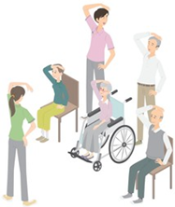  Chair Exercises  11:15 – 12pm  Mini-Basketball    1:30 – 3:30pm  BINGO
SUNDAY | MONDAY | TUESDAY | WEDNESDAY | THURSDAY | FRIDAY |  | SATURDAY
25th  10:45 – 12pm  Lutheran Church service DVD in the Edwards Rec Room  1:30 – 3:30pm    Piece by piece, let’s puzzle together | 26th  10:30 – 11:00am  Chair Exercises  11:00 – 11:30am  Ten Pin Bowling    1:30 – 2:30pm  Julie Noble Live in Concert  3:30 – 4:30pm  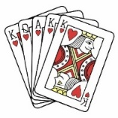  Mingle with Maxine | 27th  10:30 – 11:00am  Short Walking Group  11:00 – 11:30am  Long Walking Group  (weather permitting)  11:00 – 11:30am  Beauty Therapy    1:30- 3:30pm    Craft with Dakota | 28th  10:30 – 11:30am  Chapel  1:30 – 3:00pm  BINGO  3:00 – 3:30pm  Book Club   | 29th  10:30 – 11:00am  Chair Exercises    11:00 – 11:30am  Newspaper Reading  11:00 – 1:00pm  Lunch on board the Murray River Queen    2:00 – 3:00pm  Anne Battams Community Singalong in the Chapel | 30th  10:30 – 11:30am  Let’s Get Trivial!    10:30 – 11:30am  Scenic Car Trip    1:30 – 3:30pm  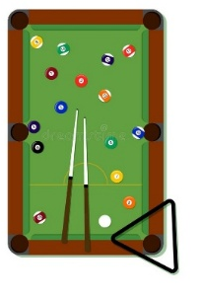  Happy Hour in the Edwards Recreation Room |  | 31st  10:45 – 11:15am  Chair Exercises  11:15 – 12pm  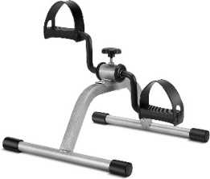  Mini-Bike Pedals  1:30 – 3:30pm  BINGO

