SUNDAY | MONDAY | TUESDAY | WEDNESDAY | THURSDAY | FRIDAY | SATURDAY
 |  |  |  | 1st New Year’s Day  10:30 – 11:30am  Chair Exercises & Mini Basketball    1:30 - 3:30pm  Games Afternoon with Choy | 2nd  10.30 – 11:30am  Let’s Get Trivial!    1:30 – 3:30pm  Relaxation and Pampering Afternoon | 3rd  10:45 – 12pm  Chair Exercises & Quoits  1:30 – 3:30pm  BINGO  
4th  10:45 – 12pm  Lutheran Church Traditional Online Service in the Edwards Rec Room  Happy Hour At LUNCH  1:30 – 3:30pm  Games Afternoon | 5th  10:30 – 11:30am  Chair Exercises & Hookey  1:30 – 3:30pm  Magic Memories with Kerri  Bring a Special Photo to Share with the Group | 6th  10:30 – 11:30am  Walking Group  (Weather permitting)    1:30- 3:30pm  Yarn a Lot with Dakota | 7th  10:30 – 11:30am  Chapel    1:30 – 3:00pm  BINGO  3:00 – 3:30pm  Book Club | 8th  10:30 – 11:30am  A Visit to Loxton Library    2:00 - 3:00pm  Anne Battams Community Singalong | 9th  10.30 – 11:30am  Let’s Get Trivial!    1:30 – 3:30pm  Craft Afternoon with Donna & Helpers | 10th  10:45 – 12pm  Chair Exercises & Mini Golf  1:30 – 3:30pm  BINGO
11th  10:45 – 12pm  Lutheran Church Traditional Online Service in the Edwards Rec Room  1:30 – 3:30pm  Bus Drive Around Town | 12th  10:30 – 11:30am  Chair Exercises & Seated Soccer  1:30 – 3.00pm  Games Fun in the Chapel  3.30 – 4.30pm  Maxine on the Piano | 13th  10:30 – 11:30am  Walking Group  (Weather permitting)    1.30 – 3:30pm  Cooking with Dakota | 14th  10:30 – 11:30am  Chapel    1:30 – 3:00pm  BINGO  3:00 – 3:30pm  Book Club | 15th  11.00am-1.00pm  Lunch at the Local  2:00 - 3:00pm  Anne Battams Community Singalong | 16th  10:30 – 11:30am  Let’s Get Trivial!  1:30 – 3:30pm  Air Hockey & Table Tennis Afternoon in the Edwards Recreation Room | 17th  10:45 – 12pm  Chair Exercises & Ten Pin Bowling  1:30 – 3:30pm  BINGO
18th  10:45 – 12pm  Lutheran Church Traditional Online Service in the Edwards Rec Room  Happy Hour At LUNCH  1:30 – 3:30pm  Yarn a Lot | 19th  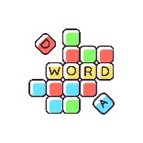  10:30 – 11:30am  Scattegories & Word Games  1:30 – 3.30pm  Let’s Watch a Movie together in the Edwards Recreation Room | 20th  10:30 – 11:30am Walking Group  (Weather permitting)    1.30pm – 3.30pm  Monthly Birthday Party Celebrations | 21st  10:30 – 11:30am  Chapel  1:30 – 3:00pm  BINGO  3:00 – 3:30pm  Book Club | 22nd  10:30 – 11:30am  Scenic Bus Trip  2:00 - 3:00pm  Anne Battams  Community Singalong | 23rd  10:30 – 11:30am  Let’s Get Trivial!    1:30 – 3:00pm  RV Reveller’s Group with John Kindness | 24th  10:45 – 12pm  Chair Exercises & Magnetic Darts  1:30 – 3:30pm  BINGO
25th  10:45 – 12pm  Lutheran Church Traditional Online Service in the Edwards Rec Room  1:30 – 3:30pm  Bus Drive Around Town | 26th Australia Day  10.30 –11:30am  Chair Exercises & Aussie Thong Toss  1:30 – 3:00pm  An Aussie Afternoon to Celebrate Australia Day  3.30 – 4.30pm  Maxine on the Piano | 27th  10:30 – 11:30am  Walking Group  (Weather permitting)  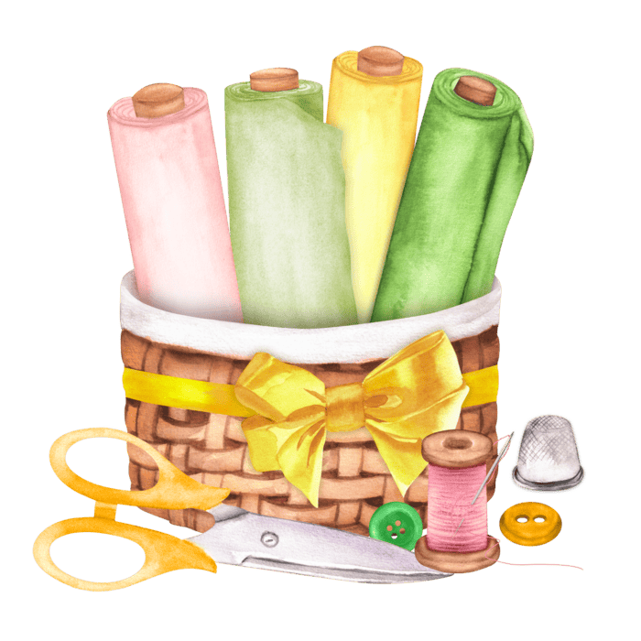  1:30- 3:30pm  Craft with  Dakota | 28th  10:30 – 11:30am  Chapel  1:30 – 3:00pm  BINGO  3:00 – 3:30pm  Book Club | 29th  10:30 – 11:30am  Scenic Bus Trip  2:00 - 3:00pm  Anne Battams  Community Singalong | 30th  10:30 – 11:30am  Let’s Get Trivial!    1:30 – 3:30pm  Summertime Reminiscing with Kerri | 31st  10:45 – 12pm  Chair Exercises & JBall Hockey  1:30 – 3:30pm  BINGO

