SUNDAY | MONDAY | TUESDAY | WEDNESDAY | THURSDAY | FRIDAY | SATURDAY
30th  10:30 – 12pm  Lutheran Church Traditional service DVD in the Edwards Rec Room  BBQ & Happy Hour at LUNCH  1:30 – 3:30pm  Games Afternoon | 31st  10:30 – 11:30am  Chair Exercises and Mini-Bike Pedals  1:30 – 3:00pm  Yarn a lot knitting group  3:00 – 3:30pm  Book Club |   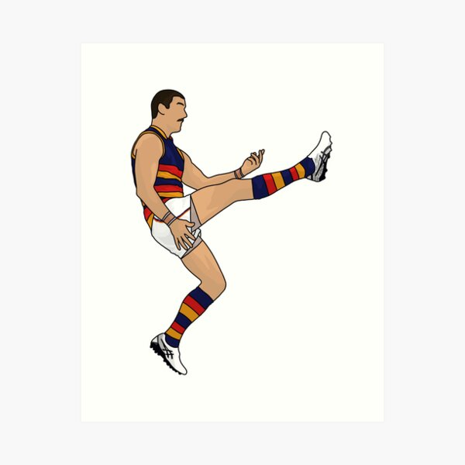 |      | 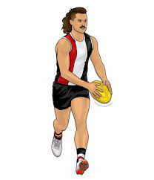  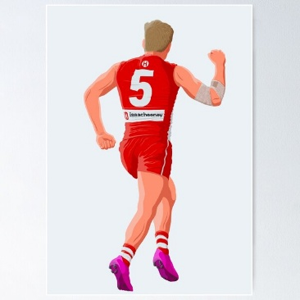 |      | 1st  10:30 – 11:30am  Chair Yoga & Mini Basketball  1:30 – 3:30pm    BINGO
2nd  10:30 – 12pm  Lutheran Church Traditional service DVD in the Edwards Rec Room  BBQ & Happy Hour at LUNCH  1:30 – 3:30pm  Games Afternoon | 3rd  10:30 – 11:30am  Indoor Bowls  1:30 – 3:00pm  Yarn a lot knitting group  3:00 – 3:30pm  Book Club | 4th Shrove Tuesday  9:00 – 10:00am  Let’s make pancakes for Shrove Tuesday  10:30 – 11:30am  Chair Exercises and Ten Pin Bowling  1:30- 3:30pm  Craft with Dakota | 5th  10:30 – 11:30am  Chapel  1:30 – 3:00pm  BINGO  3:00 – 3:30pm  Book Club | 6th  10:30 – 11:30am  A visit to the Loxton Library    2:00 – 3:00pm  Anne Battams Community Singalong |   7th  Season Begins  10:30 – 11:30am  Let’s Get Trivial  1:30 – 3:30pm  Food and Wine Festival Tasting Session | 8th  10:30 – 12pm  Chair Exercises & Hookey  1:30 – 3:30pm  BINGO
9th  10:30 – 12pm  Lutheran Church Traditional service DVD in the Edwards Rec Room  1:30 – 3:30pm  Bus Drive Around Town | 10th  Adelaide Cup Public Holiday  10:30 – 11:30am  Chair Exercises and Ten Pin Bowling  1:30 – 3:00pm  Let’s tune into the races | 11th  10:30 – 11:30am  Chair Exercises and Mini-Golf  1:30- 3:30pm  Monthly Birthday Party Celebrations | 12th  10:30 – 11:30am  Chapel  1:30 – 3:00pm  BINGO  3:00 – 3:30pm  Book Club | 13th  10:30 – 11:30am  Scenic Bus Trip  2:00 – 3:00pm  Anne Battams Community Singalong | 14th  10:30 – 11:30am  Let’s Get Trivial    1:30 – 3:00pm  Crossword Memories | 15th  10:30 – 12pm  Chair Yoga & Quoits  1:30 – 3:30pm  BINGO
16th  10:30 – 12pm  Lutheran Church Traditional service DVD in the Edwards Rec Room  BBQ & Happy Hour at LUNCH  1:30 – 3:30pm  Reminiscing no days gone by… | 17th ^{St Patricks Day}  Let’s wear GREEN today!  9:30 – 11:30am  Scavenger Hunt throughout Riverview to find pots of gold, four leaf clovers, the Irish flag and MORE!!  1:30 – 3:30pm  Paint n’ Sip topped off with an Irish treat | 18th ^{Men’s Probus – Lox Club}  10:30 – 11:30am  Walking Group  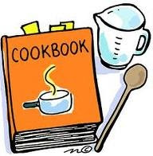  1:30- 3:30pm  Cooking Class | 19th  10:30 – 11:30am  Chapel  1:30 – 3:00pm  BINGO  3:00 – 3:30pm  Book Club | 20th  11:00 – 1:00pm  Lunch at the Local  2:00 – 3:00pm  Anne Battams Community Singalong | 21st Harmony Day  10:30 – 11:30am  Let’s Get Trivial  1:30 – 3:30pm    Cultural Afternoon for Harmony Day | 22nd  10:30 – 12pm  Chair Exercises & Mini Golf  1:30 – 3:30pm  BINGO
23rd  10:30 – 12pm  Lutheran Church Traditional service DVD in the Edwards Rec Room  1:30 – 3:30pm  Bus Drive Around Town | 24th  10:30 – 11:30am  Chair Exercises and Jball  1:30 – 3:00pm  Men’s Group  3:00 – 3:30pm  Book Club | 25th  10:30 – 11:30am  Walking Group  1:30- 3:30pm    Gardening Group | 26th  10:30 – 11:30am  Chapel  1:30 – 3:00pm  BINGO  3:00 – 3:30pm  Book Club | 27th  10:30 – 11:30am  Scenic Bus Trip  2:00 – 3:00pm  Anne Battams Community Singalong | 28th  10:30 – 11:30am  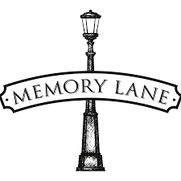  Let’s Get Trivial  1:30 – 3:30pm  Magic Memories | 29th  10:30 – 12pm  Chair Exercises & Balloon Tennis    1:30 – 3:30pm  BINGO

