SUNDAY | MONDAY | TUESDAY | WEDNESDAY | THURSDAY | FRIDAY | SATURDAY
 |  |  |  |  | 1st  9:00 – 10:00am  Pancake Morning Tea in the Chapel Kitchenette  10:30 – 11:30am  Scattegories  1:30 – 3:30pm    Gardening Group | 2nd  10:30 – 11:45am  Chair Yoga & Hookey  1:30 – 3:30pm  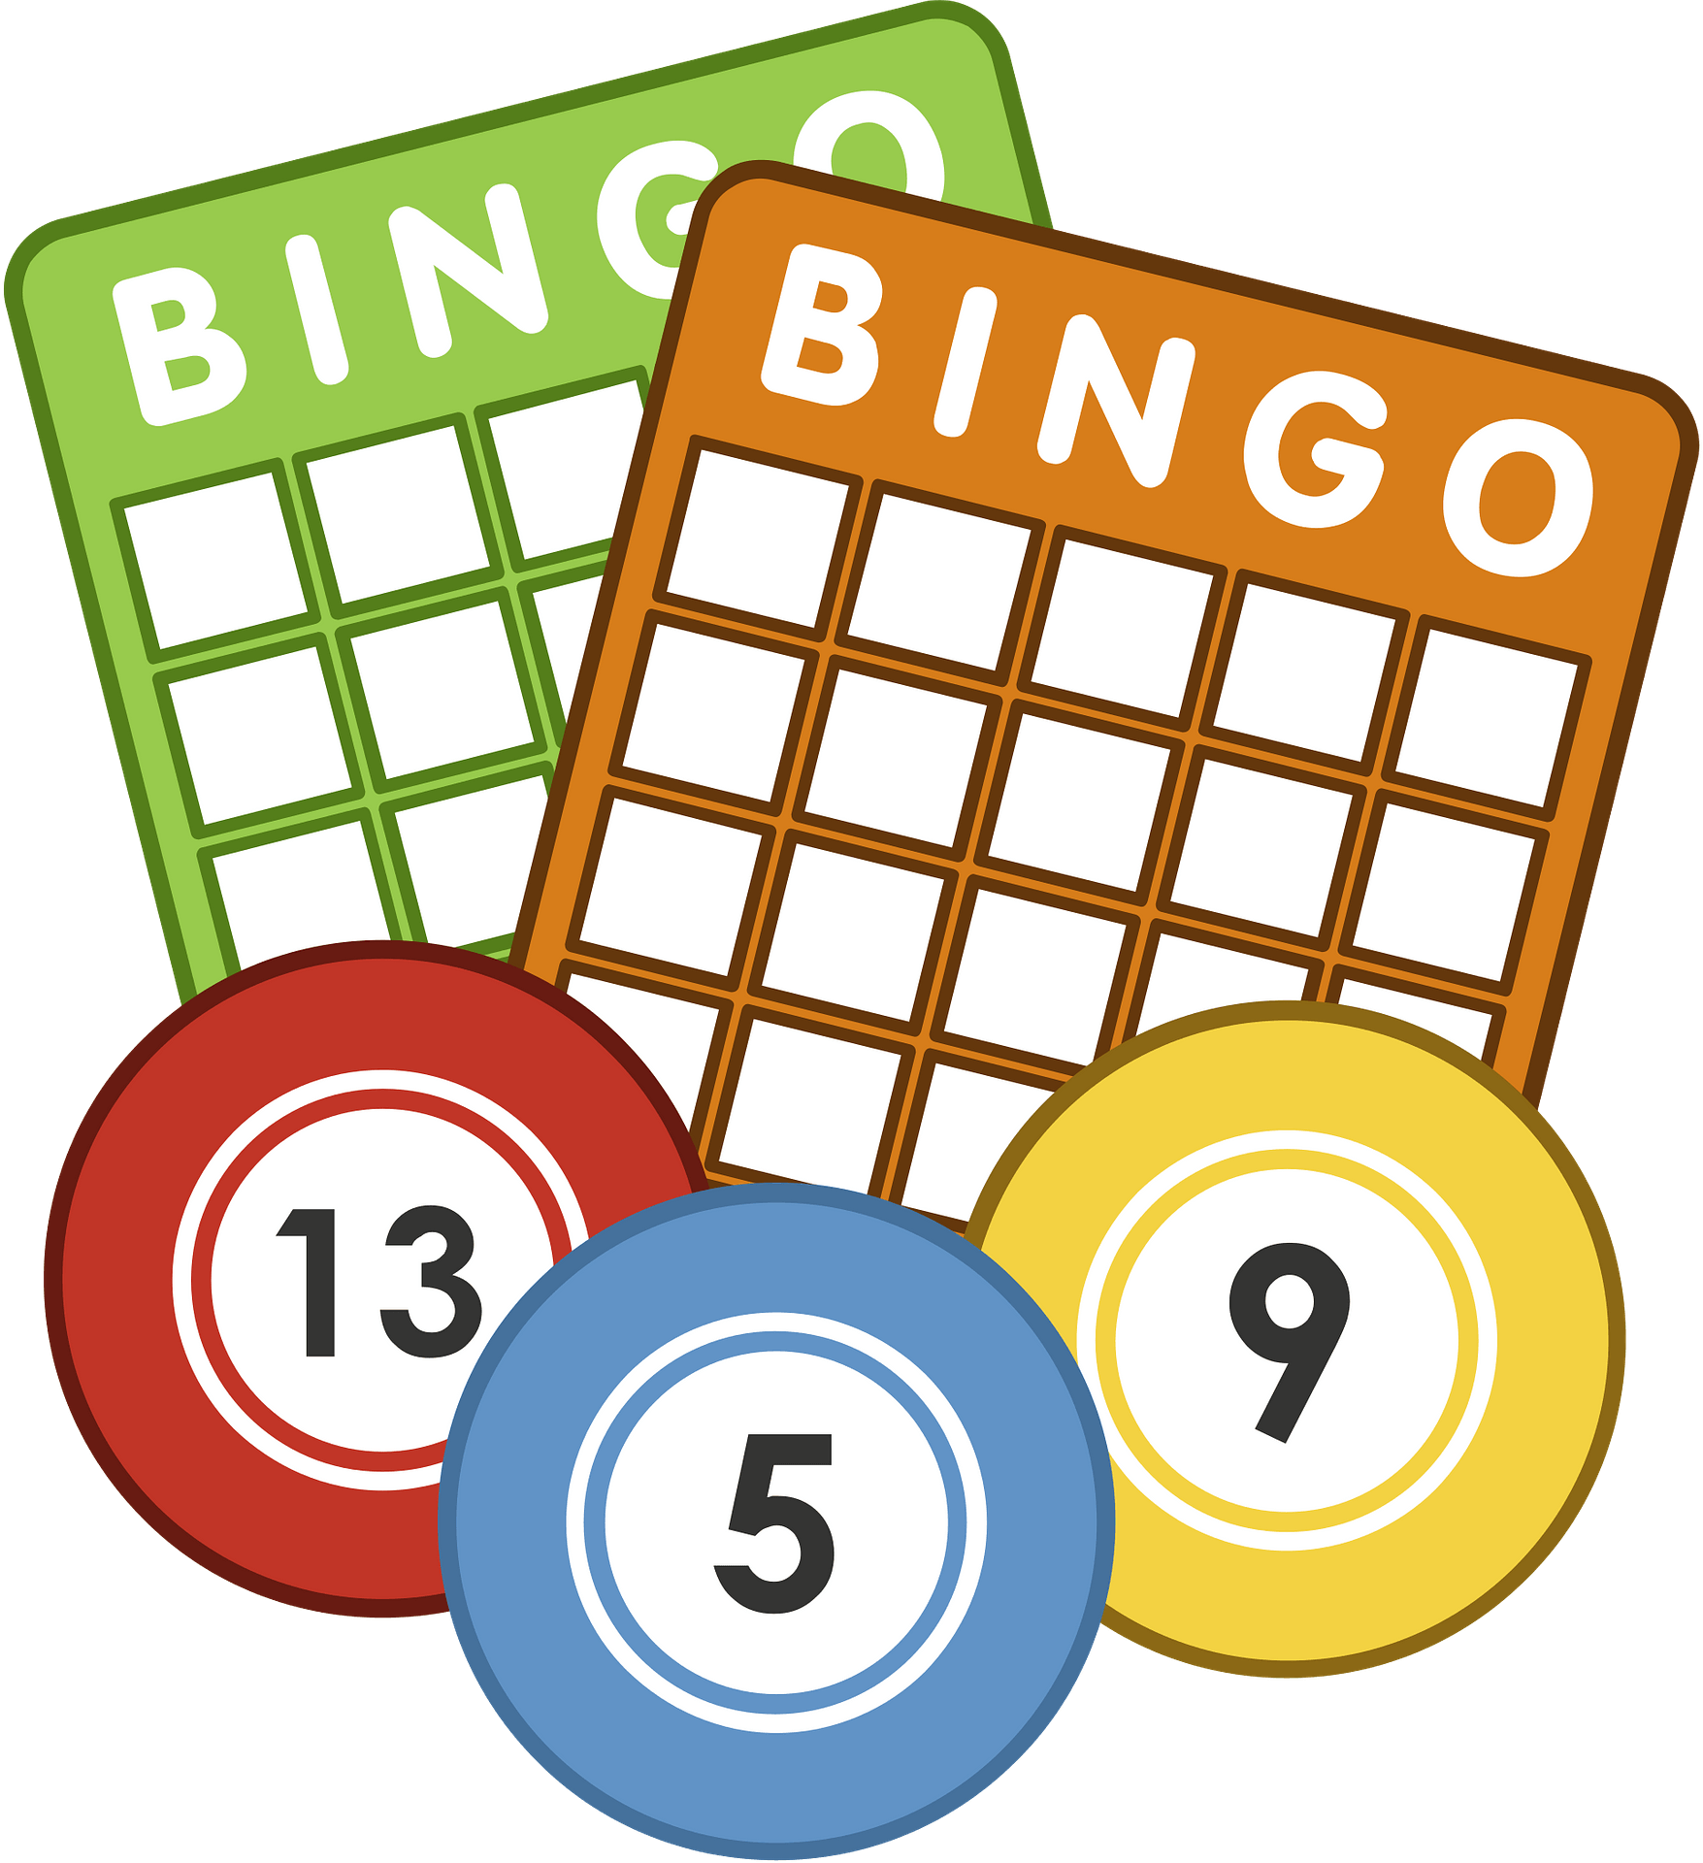  BINGO
3rd  10:30 – 12pm  Lutheran Church Traditional service DVD  BBQ & Happy hour at LUNCH  1:30 – 3:30pm  Bus ride around town | 4th  10:30 – 11:30am  JBall Hockey  1:30 – 3:00pm  Games Afternoon  3:00 – 3:30pm    Book Club | 5^{th Melbourne Cup}  10:30 – 11:30am  A morning at the races  1:30 – 3:30pm  Join us as we watch the race that stops the nation!   | 6th  10:30 – 11:30am  Chapel  1:30 – 3:00pm BINGO  3:00 – 3:30pm  Book Club  Men’s group – Bus / bike ride | 7th  10:30 – 11:30am  Chair Exercises & Newspaper Reading  2:00 – 3:00pm    Anne Battams Community Singalong in the Edwards Rec Room | 8th  10:30 – 11:30am  Let’s Get Trivial  1:30 – 3:30pm    Word Games and Quizzes | 9th  10:30 – 11:45am  Chair Yoga & Quoits  1:30 – 3:30pm  BINGO
SUNDAY | MONDAY | TUESDAY | WEDNESDAY | THURSDAY | FRIDAY | SATURDAY
10th  10:30 – 12pm  Lutheran Church Traditional service DVD  1:30 – 3:30pm  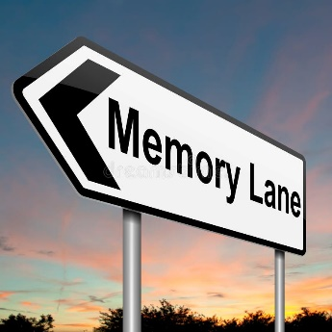  Reminiscing on days gone by… |   11th ^{Remembrance Day}  10:30 – 11:30am  Remembrance Day Service  1:30 – 3:00pm  Crossword Memories  3:00 – 3:30pm  Book Club  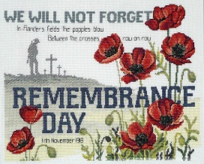 | 12th  10:30 – 11:30am  Walking Group  1:30 – 3:30pm    Let’s stir up some memories in the Chapel Kitchenette! | 13th  10:30 – 11:30am  Chapel  1:30 – 3:00pm  BINGO in the Edwards Rec Room  3:00 – 3:30pm  Book Club | 14th  10:30 – 11:30am  Chair Exercises & Newspaper Reading  10:30 – 11:45am  Bus Ride Around Town  2:00 – 3:00pm  Anne Battams Community Singalong in the Edwards Rec Room | 15th  10:30 – 11:30am  Let’s Get Trivial!  1:30 – 3:30pm  Christmas Card Making   | 16th  10:30 – 11:45am  Chair Yoga & Mini Basketball  1:30 – 3:30pm  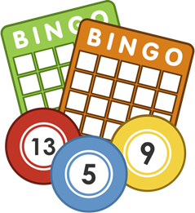  BINGO
17th  10:30 – 12pm  Lutheran Church Traditional service DVD  BBQ & Happy hour at LUNCH  1:30 – 3:30pm  Bus ride around town | 18th  10:30 – 11:30am  Chair Exercises and Magnetic Darts  1:30 – 3:00pm  Yarn a lot  3:00 – 3:30pm  Book Club | 19th ^{Men’s Probus}  10:30 – 11:30am  Walking Group  1:30 - 3:30pm  Monthly Birthday Party in the Edwards Rec Room, celebrating the November babies (Joan B, Betty B, Helen Hand Beryl L!!) | 20th  10:30 – 11:30am  Chapel  1:30 – 3:00pm  BINGO  3:00 – 3:30pm Book Club  Men’s group – Bus / bike ride | 21st  11:00 – 1:00pm  Lunch at the Local – Limited spots available  2:00 – 3:00pm Anne Battams Community Singalong | 22nd  10:30 – 11:30am  Let’s Get Trivial!  1:30 – 3:30pm    Paint n’ Sip in the Edwards Rec Room | 23rd  10:30 – 11:45am  Chair Yoga & Balloon Tennis  1:30 – 3:30pm  BINGO
SUNDAY | MONDAY | TUESDAY | WEDNESDAY | THURSDAY | FRIDAY | SATURDAY
24th  10:30 – 12pm  Lutheran Church Traditional service DVD  1:30 – 3:30pm    Let’s go outside for a chat in the sunshine! | 25th  9:00 –11:45am  Join us as we turn the Edwards Recreation Room into Christmas Wonderland!  1:30 – 3:00pm  Movie Afternoon in the Edwards Rec Room  3:00 – 3:30pm  Book Club | 26th  10:30 – 11:30am  Walking Group  1:30- 3:30pm  Let’s stir up some memories in the Chapel Kitchenette! | 27th  10:30 – 11:30am  Chapel  1:30 – 3:00pm  BINGO  3:00 – 3:30pm  Book Club | 28th  10:30 – 11:30am  Let’s decorate our Chapel and Wellbeing Centre for Christmas  2:00 – 3:00pm  Anne Battams Community Singalong in the Edwards Rec Room | 29th  10:30 – 11:30am  Let’s Get Trivial!  1:30 – 3:30pm    Ten Pin Bowling Competition | 30th  Loxton Lights Up Weekend  10:30 – 11:45am  Chair Yoga & Mini-Golf  1:30 – 3:30pm    BINGO

