SUNDAY | MONDAY | TUESDAY | WEDNESDAY | THURSDAY | FRIDAY | SATURDAY
     | 1st International Joke Day  9:30 – 10:30am  Pet Therapy with Leo  10:30 – 11:30am  Chair Exercises and a belly laugh!!  1:30 – 3:00pm  Indoor bowls  3:00 – 3:30pm  Book Club | 2nd  10:30 – 11:30am  Chair Exercises and Ten Pin Bowling  1:30 – 3:30pm  Word Games and Quizzes  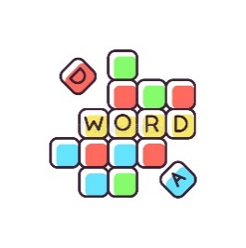 | 3rd  10:30 – 11:30am  Chapel  1:30 – 3:00pm  BINGO  3:00 – 3:30pm  Book Club  Men’s group – Bus / bike ride | 4th  10:30 – 11:30am  Chair Exercises and Seated Soccer  2:00 – 3:00pm    Anne Battams Community Singalong | 5th  9:00 – 10:00am  Pancake Morning Tea  10:30 – 11:30am  Scattegories  1:30 – 3:30pm    Craft with Anna da Costa | 6th  10:30 – 11:45am  Chair Yoga and Quoits  1:30 – 3:30pm  BINGO  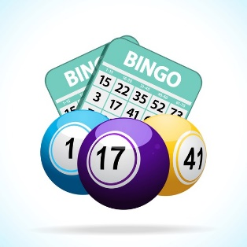
7th Naidoc Week Begins  10:30 – 12pm  Lutheran Church service DVD in Rec Room  BBQ & Happy hour at LUNCH  1:30 – 3:30pm  Games Afternoon | 8th Dress up in Naidoc Week colours  10:30 – 11:30am  Chair Exercises and Magnetic Darts  1:30 – 3:00pm  Naidoc Week  3:00 – 3:30pm  Book Club | 9th  10:30 – 11:30am  Bright Hour with Pastor Avito and Anna  1:30- 3:30pm    Monthly Birthday Party!! | 10th  10:30 – 11:30am  Chapel  1:30 – 3:00pm  BINGO  3:00 – 3:30pm    Book Club | 11th  11:00 – 1:00pm  Lunch at the Local (limited spots available)  2:00 – 3:00pm  Anne Battams Community Singalong | 12th  10:30 – 11:30am  Let’s Get Trivial  1:30 – 3:30pm    Craft with Anna da Costa | 13th  10:30 – 11:45am  Chair Yoga and Mini-Golf  1:30 – 3:30pm    BINGO
SUNDAY | MONDAY | TUESDAY | WEDNESDAY | THURSDAY | FRIDAY | SATURDAY
14th  Bastille Day  10:30 – 12pm  Lutheran Church Traditional service DVD in Rec Room  1:30 – 3:30pm  Bastille Day Celebrations | 15th  10:30 – 11:30am  JBall - Hockey  1:30 –3:00pm  Yarn a lot  3:00 – 3:30pm  Book Club | 16th ^{Men’s Probus}  10:30 – 11:30am  Chair Exercises and Mini-Bike Pedals  1:30 – 3:30pm  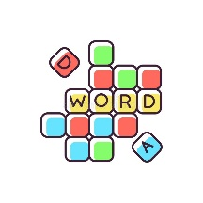  Word Games and Quizzes | 17th  10:30 – 11:30am  Chapel  1:30 – 3:00pm  BINGO  3:00 – 3:30pm  Book Club  Men’s group – Bus / bike ride | 18th  10:30 – 11:30am  Chair Exercises and Mini-Basketball  2:00 – 3:00pm    Anne Battams Community Singalong | 19th  10:30 – 11:30am  Let’s Get Trivial!  1:30 – 3:30pm  Laying of the Foundation Stone 60th Year Commemoration Service with Pastor Avito | 20th  10:30 – 11:45am  Chair Yoga and Quoits  1:30 – 3:30pm  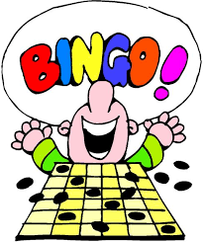  BINGO
21st  10:30 – 12pm  Lutheran Church Traditional service DVD in Rec Room  BBQ & Happy hour at LUNCH  1:30 – 3:30pm  Games Afternoon | 22nd  10:30 – 11:30am  Chair Exercises and Balloon Tennis  1:30 – 3:00pm  Chair Basketball Competition  3:00 – 3:30pm  Book Club | 23rd  10:30 – 11:30am  Bright Hour with Pastor Avito and Anna  1:30- 3:30pm    Let’s Get Trivial! | 24th  10:30 – 11:30am  Chapel  1:30 – 3:00pm  BINGO  3:00 – 3:30pm  Book Club | 25th  10:30 – 11:30am  Chair Exercises and Hookey  2:00 – 3:00pm  Anne Battams Community Singalong | 26th Olympics’ Begin  10:30 – 11:30am  Cup Pong and Stacking Fun  1:30 – 3:30pm    Discus Throwing and Ring Toss |   27th  10:30 – 11:45am  Chair Exercises & Chair Basketball  1:30 – 3:30pm  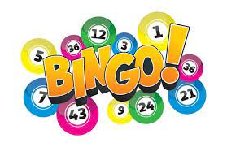  BINGO
SUNDAY | MONDAY | TUESDAY | WEDNESDAY | THURSDAY | FRIDAY | SATURDAY
28th  10:30 – 12pm  Lutheran Church Traditional service DVD in Rec Room  1:30 – 3:30pm    Bus Tour Around Town | 29th  10:30 –11:30am  Chair Exercises and Bean Bag Toss  1:30 – 3:00pm  Table Tennis Fun  3:00 – 3:30pm  Book Club | 30th  10:30 – 11:30am  Chair Exercises and Ten Pin Bowling  1:30- 3:30pm    Hookey and Magnetic Darts | 31st  Are you missing your ones?? If you would like to Face time or Skype your loved ones on Riverview’s iPad, we would LOVE to help you!  Families can contact Riverview on 8584 7370 and residents can ask at the reception desk, and we can set up a time for you.    Families can contact Riverview on 8584 7370 and residents can ask at the reception desk, and we can set up a time for you.  10:30 – 11:30am  Chapel  1:30 – 3:00pm  BINGO  3:00 – 3:30pm    Book Club

